Exercise 3: Assertions in JUnit
Scenario:
You need to use different assertions in JUnit to validate your test results.
Implementation:
AssertionTest.java
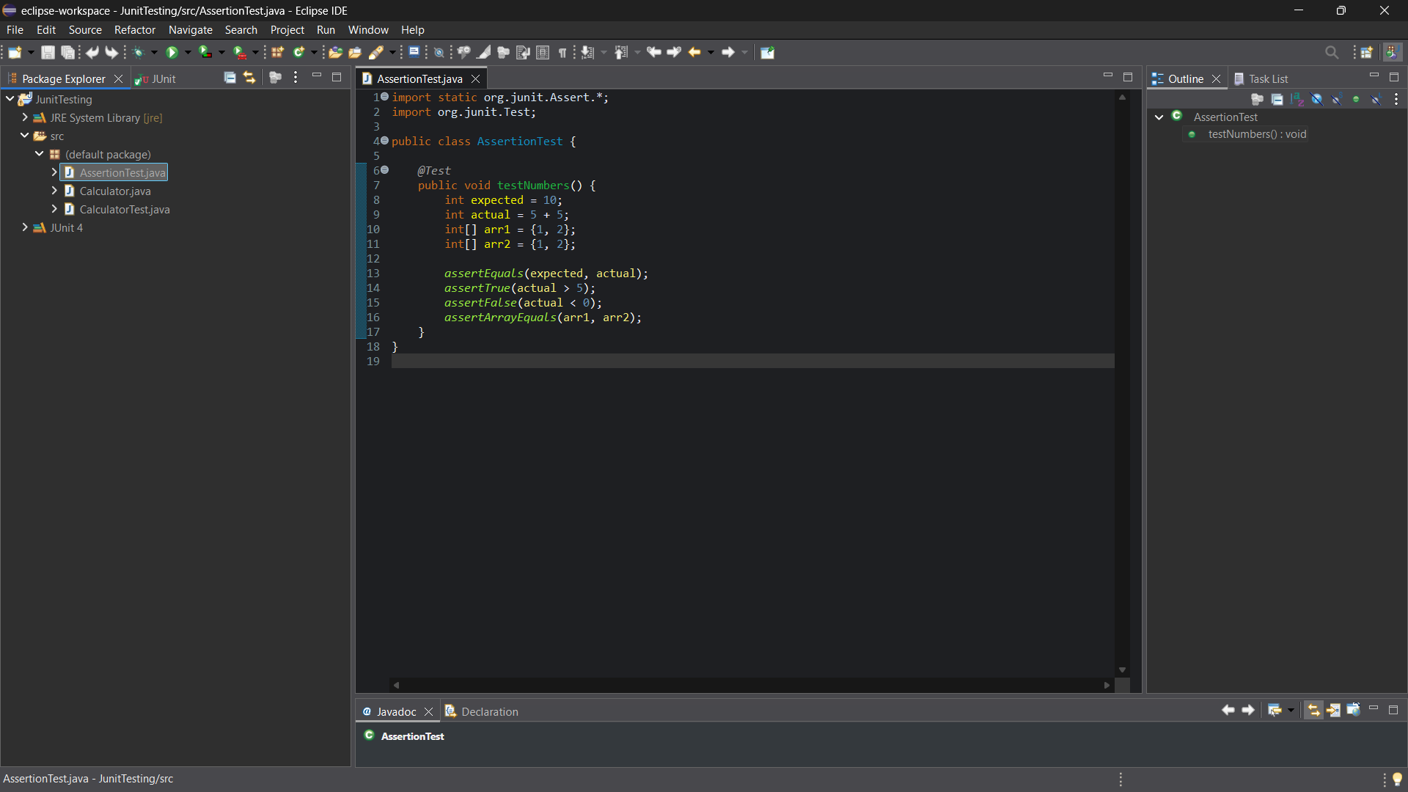
OUTPUT:
